**Simulation-7**

**Aim: Application of MATLAB for design of field and armature control of a DC machine.**

**Software Required:**

* MATLAB SIMULINK

**Field Controlled Method**

**Theory:**

When using the field control method for DC motors, the field is weakened to increase the speed or it can be strengthened to reduce the motor’s speed. Attaining speeds that are above the rated speed can be achieved by providing variable resistance in series to the field circuit, varying the reluctance of the magnetic circuit, or by varying the applied voltage of the motor to the field circuit (with constant voltage being supplied to the armature circuit).

**Observations:**

* In this simulation, the armature resistance is constant but the shunt field resistance is varied.
* As the shunt field resistance is increased the field current decreases and also speed initially increases and the it decreases

|  |  |  |  |  |  |
| --- | --- | --- | --- | --- | --- |
| S.No. | Armature resistance | Shunt field resistance | Field current (I) | Armature voltage | Speed (RPM) |
| 1. | 0.0000001 | 10 | 2.529 | 240 | 4092 |
| 2. | 0.0000001 | 50 | 1.799 | 240 | 4984 |
| 3. | 0.0000001 | 100 | 1.298 | 240 | 4771 |
| 4. | 0.0000001 | 500 | 0.4103 | 240 | 1954 |
| 5. | 0.0000001 | 1000 | 0.2212 | 240 | 1036 |
| 6. | 0.0000001 | 5000 | 0.0472 | 240 | 151 |
| 7. | 0.0000001 | 10000 | 0.0238 | 240 | 30.72 |

*Table 1: Shows values of field-controlled method of DC machine.*

**Circuit Simulated in MATLAB**

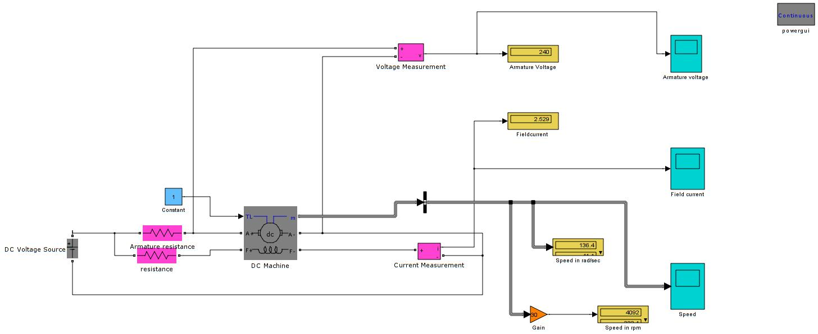

*Fig 1: SIMULINK circuit of field control of a DC machine*

**Output waveforms of Field-controlled method:**

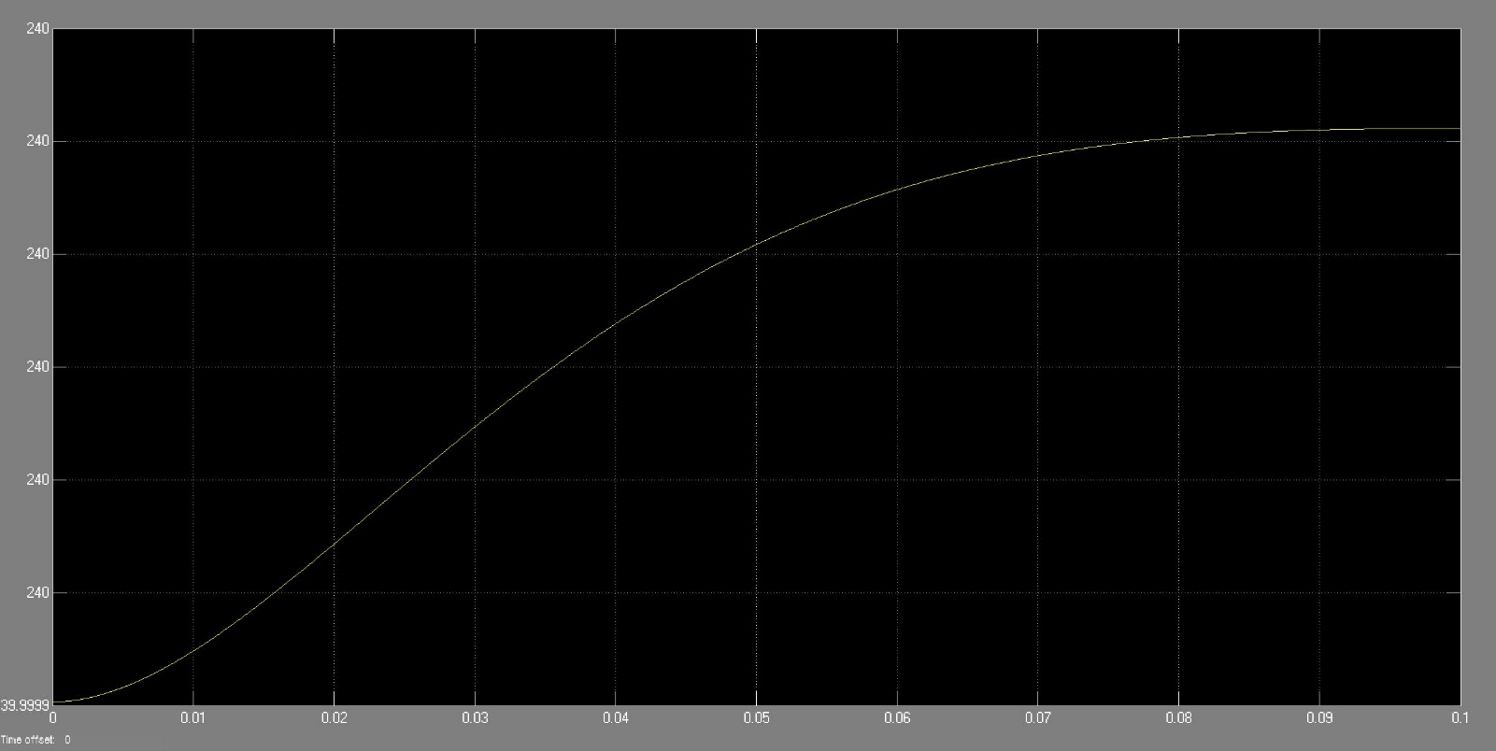

*Fig 2: SIMULINK output of armature voltage*

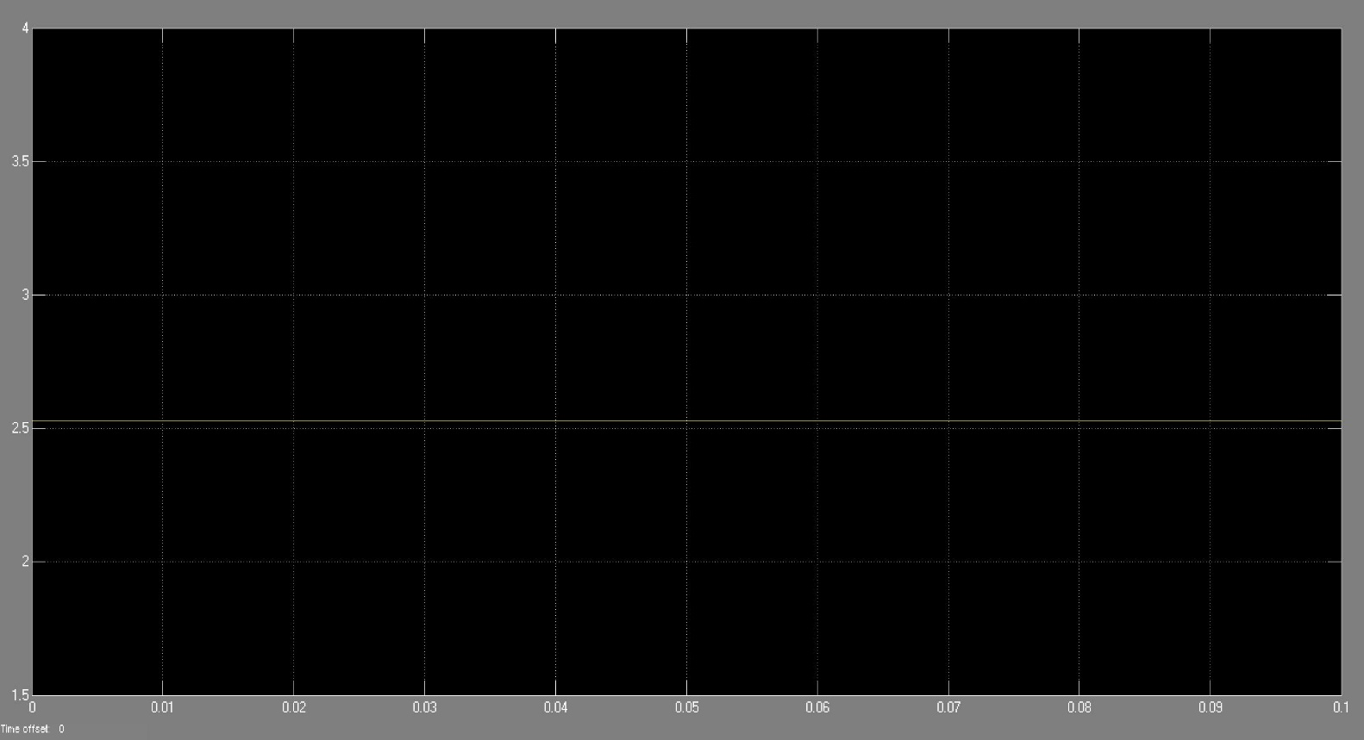

*Fig 3: SIMULINK output of field current.*

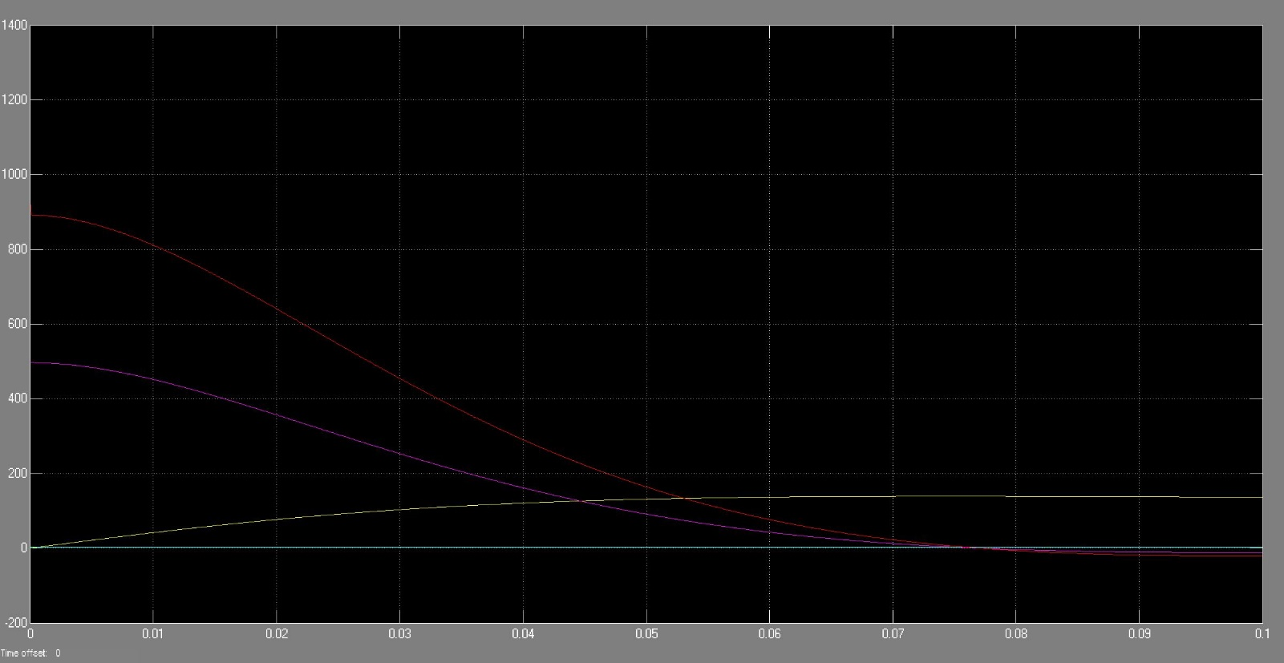

*Fig 4: SIMULINK output of speed.*

**Armature Controlled Method**

**Theory:**

With armature control the voltage is varied using several methods. One way is by implementing armature resistance, which involves connecting a variable resistance in series to the circuit of the armature. Once resistance has been increased, the current flow through the circuit is reduced and the armature voltage drop is less than the line voltage. This in turn reduces the motor speed in proportion to the voltage that’s being applied. The armature resistance control method is used in applications that require speed variation for shorter periods of time, not continuously. Other methods of armature control are armature voltage control and shunt resistance control.

**Observations:**

* In this simulation, the armature resistance is varied but the shunt field resistance is remains constant
* As the armature resistance is increased the field current is constant, armature voltage and speed decreases gradually.

|  |  |  |  |  |  |
| --- | --- | --- | --- | --- | --- |
| S. No | Armature resistance (Ω) | Shunt field resistance (Ω) | Field current (I) | Armature voltage (V) | Speed (RPM) |
| 1 | 10 | 0.00000001 | 2.827 | 44.54 | 528 |
| 2 | 50 | 0.00000001 | 2.827 | 5.376 | 46.56 |
| 3 | 60 | 0.00000001 | 2.827 | 3.512 | 24.08 |
| 4 | 70 | 0.00000001 | 2.827 | 2.168 | 7.886 |
| 5 | 75 | 0.00000001 | 2.827 | 1.628 | 1.378 |

*Table 2: Shows values of armature-controlled method of DC machine.*

**Circuit Simulated in MATLAB**

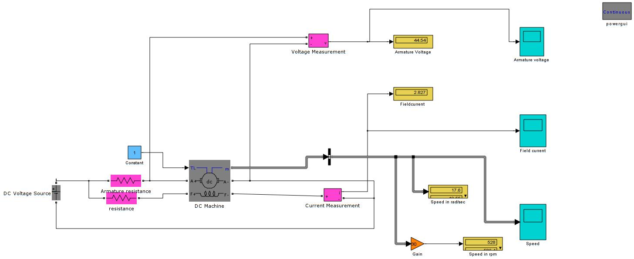

*Fig 5: SIMULINK circuit of armature control of a DC machine.*

**Output waveforms of Armature-controlled method:**

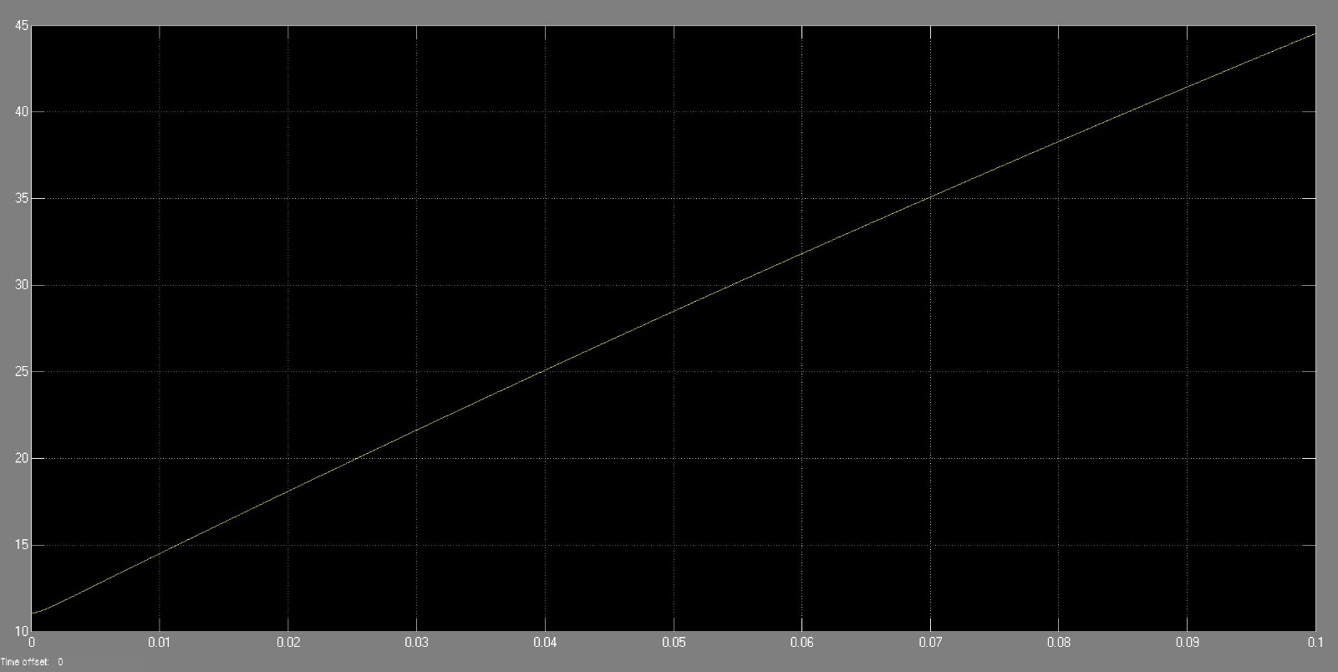

*Fig 6: SIMULINK output of armature voltage.*

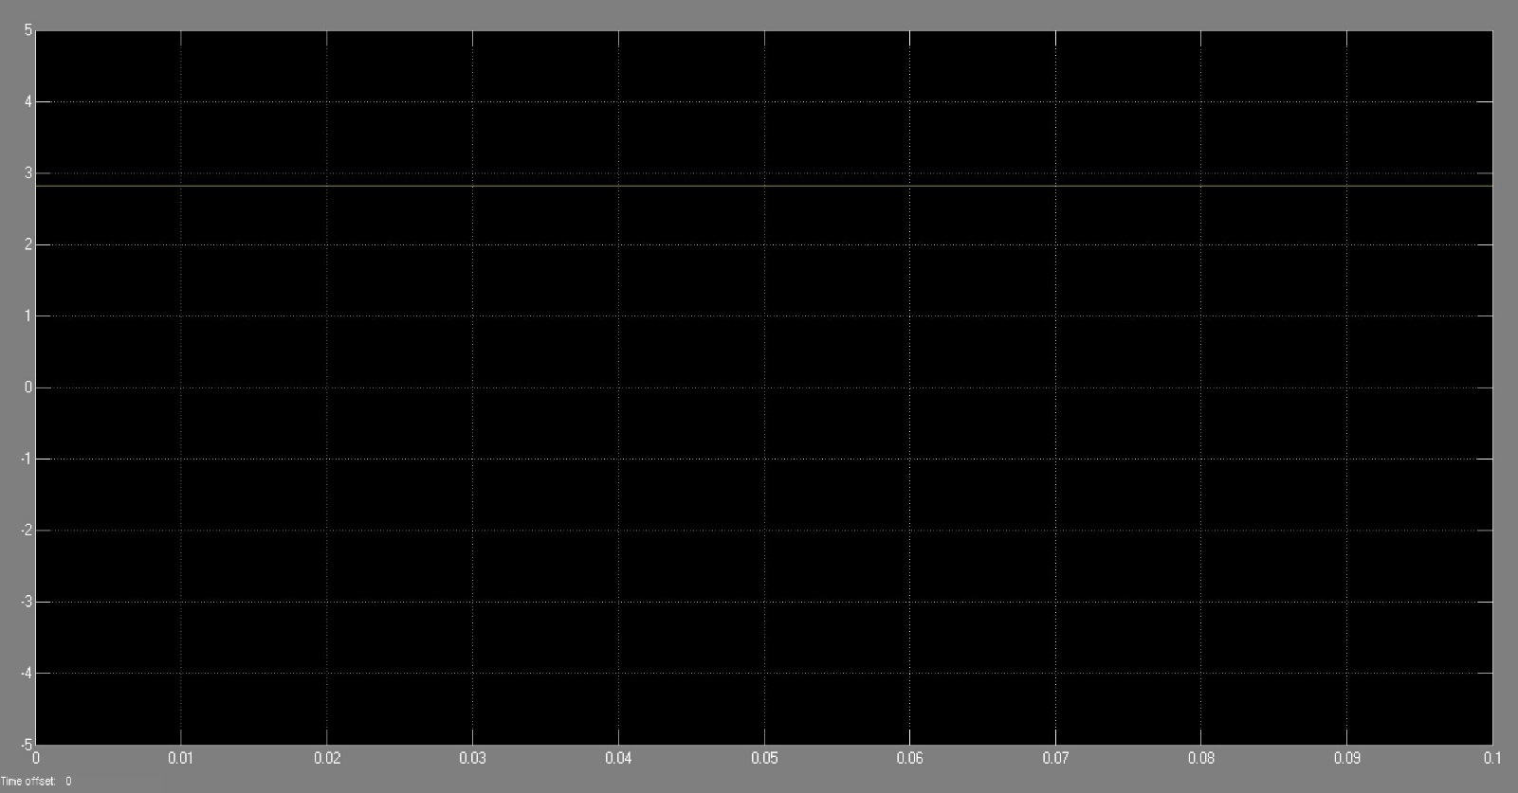

*Fig 7: SIMULINK output of field current.*

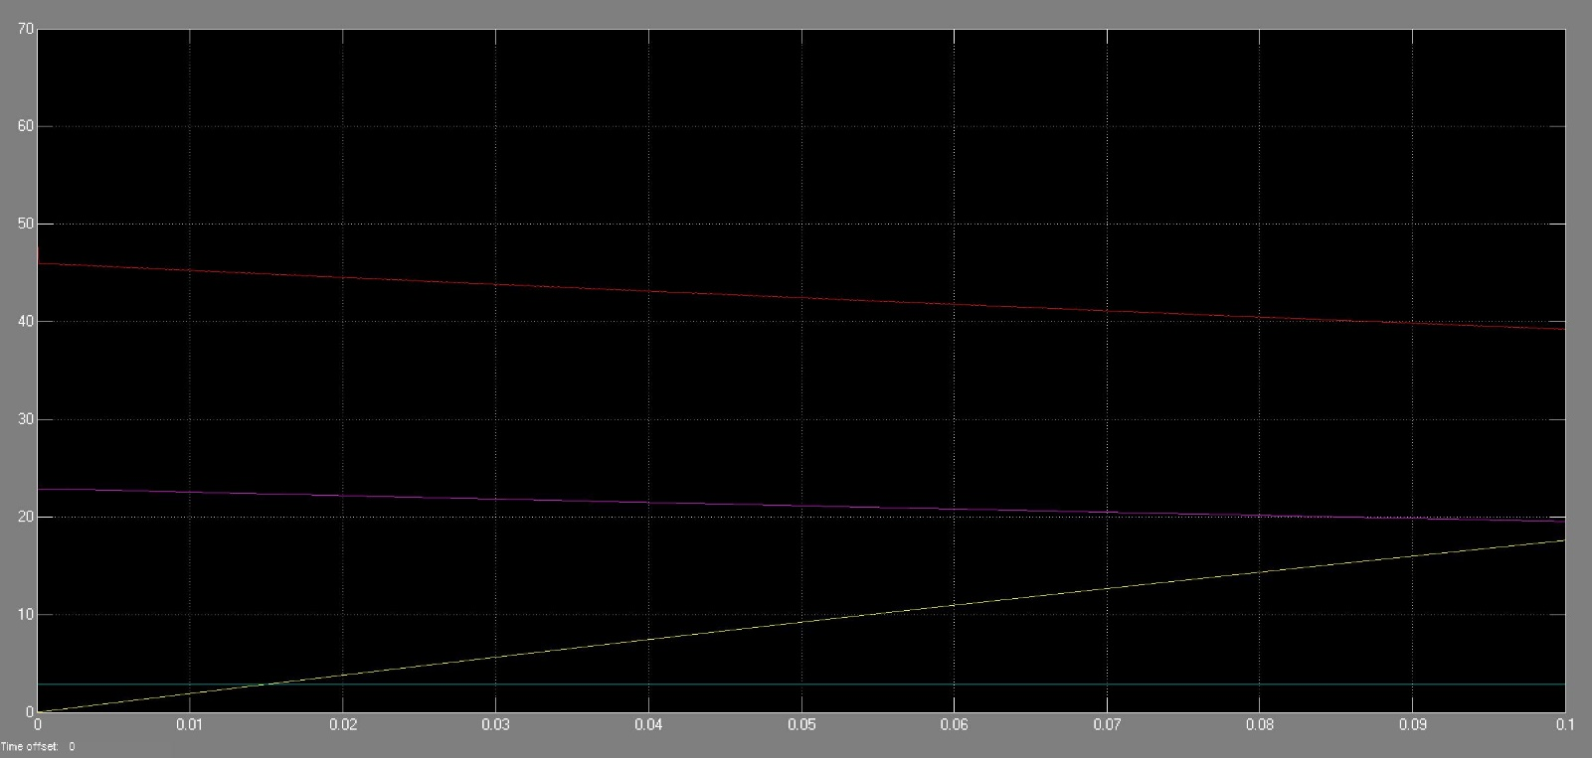

*Fig 8: SIMULINK output of speed.*

**Result:** The outputs of field and armature control of a DC machine has been obtained in MATLAB Simulink and the result has been verified.